The 1939 Register
Summary
The 1939 register for England & Wales was compiled from forms filled in by householders on 29th September 1939, shortly war was declared on Germany. After the register was compiled, the original forms were destroyed. It was used initially to issue identity cards and ration books and later by the National Health Service which came into being in 1948. The NHS updated the paper register with marriages and deaths until 1951, after which it was put on computer. Findmypast have scanned the paper register and are opening the records of those who are dead or known to be born more than 100 years ago as of now. Thus, there are weekly updates taking place as more people meet one of these criteria.

The register gives the first forename, middle initials (or sometimes a full second forename), surname, address, a schedule number with a sub-number within each household, gender, exact birth date (day, month, year), marital status and occupation of those living on 29th September 1939 who were not on duty in the armed forces. Places of birth and relationships are not given.

From 16th February 2016, Findmypast have included the 1939 register in the annual subscription. That includes the public library edition, from which it can be downloaded to a memory stick or printed. Refunds on unused credits will be given to subscribers. Credits can still be used as an alternative to subscription (£6.95 for one household, £24.95 for five and £54.95 for fifteen). It can be accessed free at The National Archives (TNA), Kew. While images cannot be downloaded from TNA computers, they can be from those at the London Family History Centre which subscribes to Findmypast and which is located on the same floor.

Details of the content
The 1939 register has been referred to as a "census substitute", but it differs in principle from a census in that it has moved from being merely a "snapshot" on the date that it was taken. It has moved in two ways, firstly through the updating by the NHS and secondly through more and more records being opened with Findmypast's weekly updates. Of course, as noted above, the content also differs.

When making a search, the information initially displayed is only the forename and surname of the person, year of birth and the local authority. It is rather difficult, sometimes, to pick the right local authority for the person sought. Thus, one might think that Nottingham C.B. (County Borough) would be the right place to find a person in Stoke Lane, Carlton NG4. Actually, the authority is Carlton U.D. (Urban District).

Clicking on "Preview" brings up the transcript, which shows the names, exact date of birth, marital status and occupation. As mentioned above, no family relationships are recorded in the register, but the preview does show who else is in the household, by name if the entry is open and anonymously if it is closed. The street name and house number or name are also given. An example is shown below, in print mode.

Beneath the transcript three maps are provided, showing the area at different dates, for example 1888-1913 OS 6 inches to the mile, 1937-61 OS 1: 25000 and present day. Also provided are so-called infographics, which give some population statistics for the local authority area. Thus, Carlton U.D. had 31,135 people in 9,373 households and the 10 most frequent surnames were Smith, Taylor, Brown, Wright, Wilson, Harrison, Ward, Watson, Green and Johnson. Photographs (from the Trinity Mirror Library) and newspaper cuttings relating to the area also appear. Thus, here there was a cutting from the Nottingham, Evening Post of 31st July 1939 showing the Earl of Munster opening Carlton Drill Hall. When I accessed the same transcript on another occasion, different pictures and cuttings appeared.

A TNA reference is provided in the transcript.

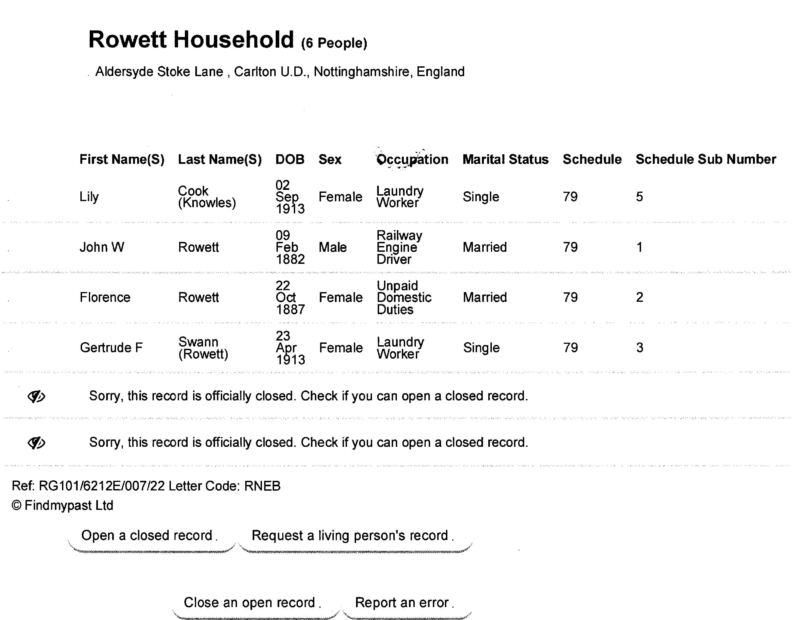

From there, it's usually worth calling up the image of the page, as illustrated by the sample page below.
Referring now to the image and working from left to right, the address, not fully visible, is followed by a schedule number of the household and a sub-schedule allotting a number to each person within the household.

The name column often shows a surname struck through and replaced by another, as a result of updating of the register by the NHS to show the new name of a woman who has subsequently married. One can sometimes see a date placed against the changed record. One such example reads: "Butler Ellen ECIA 25.11.68 NN BALES". It appears that after the death of her husband, she re-married to a Mr Bales, apparently at around 25th November 1968. However, the date is merely that on which her new name ("NN") was reported to the NHS. In fact she re-married in 1960. Fortunately, a wide enough search was done to capture this event in the GRO marriage index. In the sample page, "Knowles Lily M.RND 1-10-45 COOK" was a much quicker correction, as Lily Knowles' marriage to Mr. Cook is registered in the third quarter of 1945. The significance of the codes "ECIA" and "M.RND" is not known to me. These updates that occurred when a woman married and changed her name can be tracked, in that Findmypast have recorded both names with the new name first, for example "Lily Cook (Knowles)".

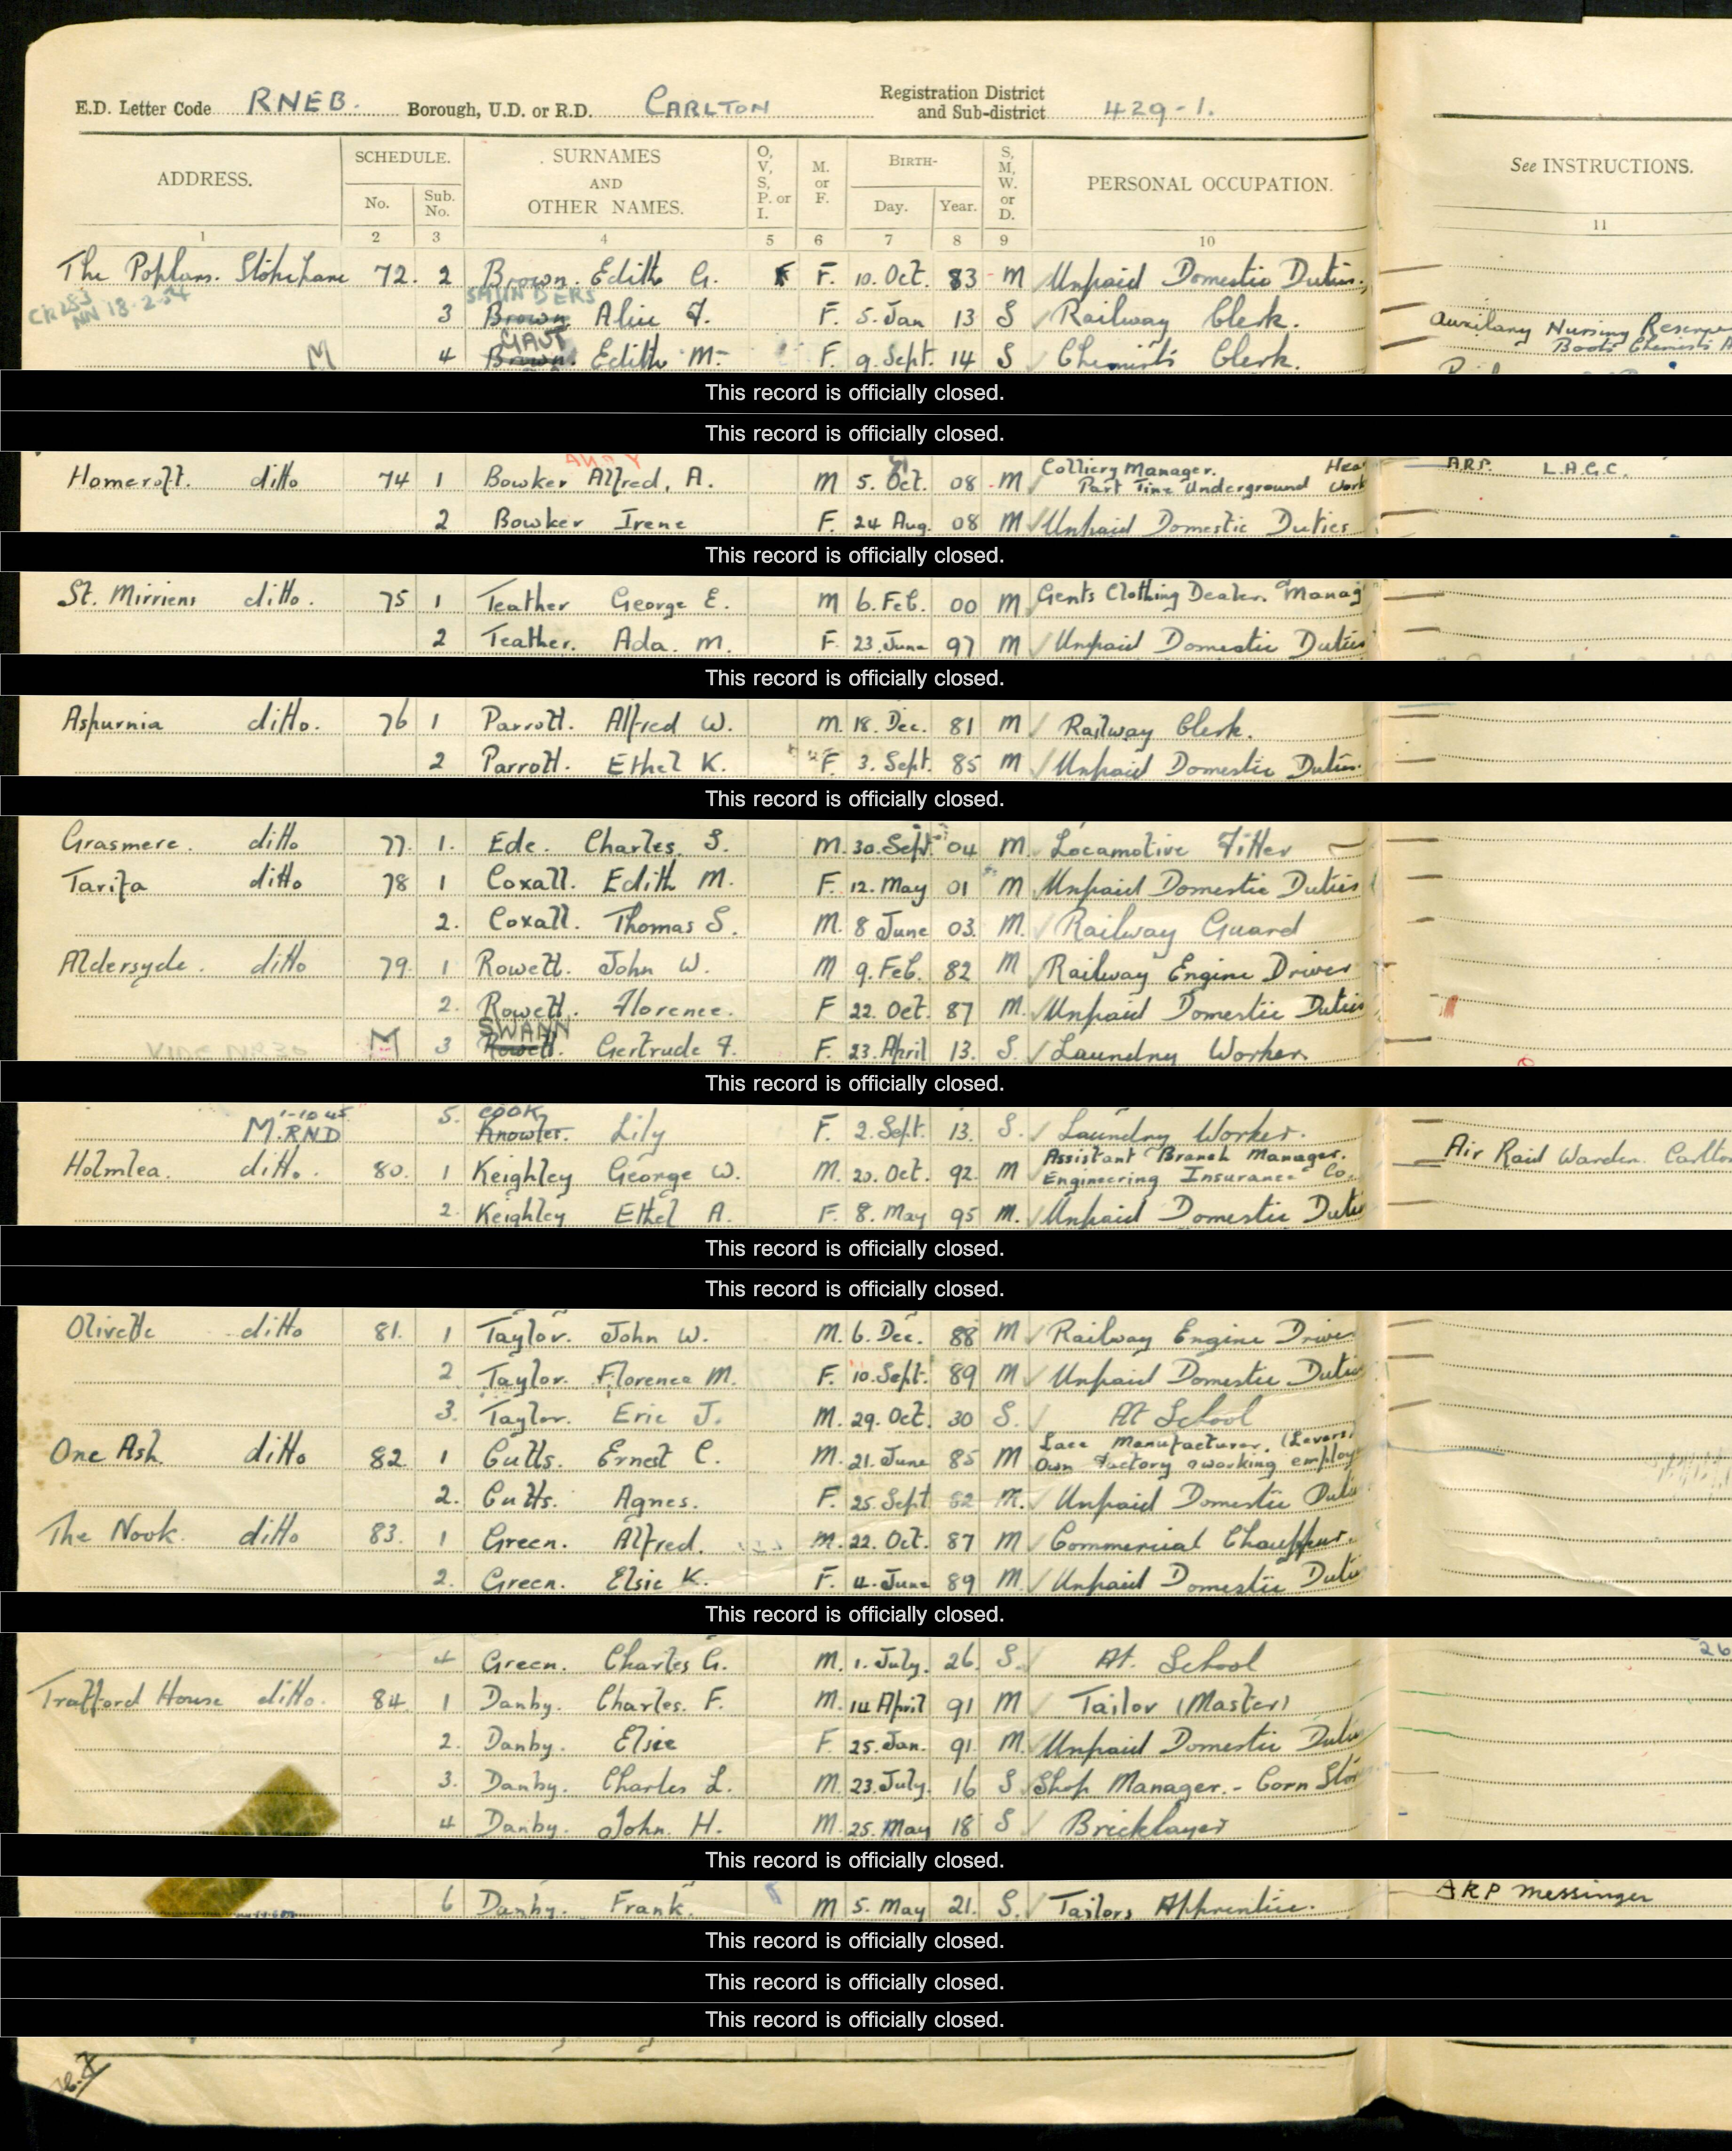

The NHS has updated the register, but was formed in 1948, so what about marriages and deaths from 30th September 1939 until then ? Many such updates like that for Lily Knowles have taken place, presumably through the issue of medical cards with NHS numbers that were the same as those of identity cards. However, according to Myko Clelland, Partnership & Outreach Manager of Findmypast, coverage of such events is unreliable. Where the person recorded has subsequently died, the entry is struck through by a red line An example is given below.
Those who were on active service in the armed forces and either overseas or stationed in their military residences, i.e. barracks, ships, airfields and so on, are not shown, but if at home on leave might be. For example, William G N Cutts' entry gives his occupation as "F Lieut 40 Group RAF Abing...". (The last few characters of "Abingdon" were not filmable owing to the binding of the register, a frequent occurrence. The entry is struck through by a red line, indicating that he died before the paper register closed in 1991. Sure enough, his death is registered in 1980 in Bakewell Registration District, the GRO death index giving the same date of birth as in the 1939 Register.)

The column O V S P or I, normally blank, has been completed in institutions such as prisons, hospitals, asylums and hotels: O = Other, V = Visitor, S = Servant, P = Patient, I = Inmate. In an example displayed by Myko Clelland, a prison governor's wife was classed as a visitor.

After the gender column comes the exact date of birth. In most instances this will tally with the date on a birth certificate, in the GRO deaths index, from the second quarter of 1969 onwards or a foreign death index. However, there are instances in which it is wrong by exactly a year, apparently owing to miscalculation or misrecollection.

The marital status column includes the symbol "D" for a divorcee. A search of the name Whitehouse showed only 9 divorces, which included 2 people of another name who subsequently married a Whitehouse.

Occupations are frequently recorded in meticulous detail, in case they could be useful in a military emergency. A simple example is "Vertical borer Heavy lifter."

Frequently, part of the opposite facing page can be seen. This was used for notes: in the sample page George W. Keighley is shown as an air raid warden. According to Myko Clelland, these opposite pages also give causes of death which were allotted a code number.

The unexpected guest
Some people will not be found in the place expected, because of operation "Pied Piper" in which over 3½ million people were displaced within the first three days of war. Mostly, they were displaced within the United Kingdom, but some, nearly all children, were evacuated overseas. The country was divided into zones, classified as "evacuation" (unsafe), "neutral", or "reception", with priority evacuees being moved from the major urban centres and billeted on the available private housing in more rural "reception" areas. Each area covered roughly a third of the population.

A register of the dead
Closed entries are not searchable. That means, of course, that if a person with a year of birth between 100 years ago and 29th September 1939 comes up in a search, he or she ought to be dead.

Mistakes in closure of records
Of course, errors do occur and if a person's record is open when it ought to be closed, this can be reported to Findmypast and will then be shut down very quickly, usually within 48 hours (72 hours at a weekend). Conversely, records that ought to be open, but are not, can be reported via the website, but the only evidence of death that is acceptable, they say, is a death certificate. They also require the address as at 29th September 1939, for which a search in directories or electoral rolls might be required if no appropriate other member of the family is revealed by a search.

Transcription errors
Unlike the 1911 census, normally completed by the head of household in his own hand, the 1939 register entries were written by the enumerator, a potential source of copying error. Mistranscriptions are evident, as in censuses. For instance, a search in the surname Whitehorse, with no variations allowed, gave 13 entries, yet this surname does not exist in England & Wales, nor do Whitchouse (6 entries) and Whitehonse, which yielded a single household with 3 entries for it. One can search with or without surname variations: Whitehouse gave 22,214 entries with variants allowed and 10,970 without, probably rather an extreme example. The apparently low latter figure, compared with what would emerge from a census, is doubtless accounted for by the redactions of children and others still alive and less than 100 years old. Problems in searching mistranscribed entries are sometimes overcome by more advanced search techniques. For example, by using a known date of birth and the Bur* wild card surname, I found Minnie A. Burrill mistranscribed as Murris A. Burnill. A mistranscription of the plainly written surname Merritt as Mettitt was found by a search that omitted forenames and merely specified the forename Alexander and, as another member of the household, Kate (his wife). In another instance, a plainly written Thomas Saunderson was mistranscribed as Sanderson, even though other members of the same household were correctly transcribed, which shows the value of searching in the name of another member of the same family. Findmypast do correct mistranscriptions reported to them, although only if the mistake is plain on the face of the register.

Findmypast claim 98.5 percent accuracy of transcription of all readable entries. To clarify, this means all entries except those in which the data is totally obscured, by adhesive tape or an ink blot for example. Where it is partly legible, it will be partly transcribed.

Searching by address
It is possible to search by address, but to find a particular household can take a little time and patience, because the images are arranged in the order of the household schedule, presumably the enumerator's walk when distributing the forms to be filled in. My own road presented the added difficulty of having been misspelt.

Other registers
There are two supplemental paper registers which are not available to the public. One covers those on duty in the armed forces, for example soldiers at an army barracks. The other covers those born after 29th September 1939 and before the paper register ended in 1951. Findmypast is trying to get Ministry of Defence permission to scan the closed armed forces register.

Registration was also carried out in Scotland and Northern Ireland, but the records have not been digitised. To access a Scottish household, there is an official fee of £15 for a manual search, by address. In Northern Ireland, a Freedom of Information request is necessary and currently (March 2016) there is a long delay, of about 12 weeks. A Register was compiled in the Isle of Man, but is currently lost.

In the Channel islands, which are part of the British Isles, but not the United Kingdom, the Germans, who invaded the islands in 1940, issued identity cards, These cards logged a person’s name, maiden name, address, place and date of birth, and occupation. Each card was accompanied by a blue form that contained extra information not on the cards, including colour of hair, colour of eyes, physical peculiarities and military service. Names of children under the age of 14 were noted on the back of the father’s card, and each adult’s photo was attached to the front. The cards have been digitised and can be searched, although there is a fee for downloading the images.

Acknowledgement
This article draws on talks given by Myko Clelland of Findmypast, to whom many thanks, as well as my own experiences.

Keith Percy

